Project Plan NSW Traffic Penalty Data Analyser

Assignment part A: 2810ICT Software Technologies

Joshua Thomas - s5220078

Roger Harley - s5221666

Contents

**1.0** **Introduction** 2

**1.1** **Background** 2

**1.2** **Scope** 2

**1.3** **Document contents** 2

**2.0** **Work Breakdown Structure** 3

**2.1** **Work Breakdown Structure Data** 3

**2.2** **Work Breakdown Structure Diagram** 4

**3.0** **Activity Definition & Estimation** 5

**4.0** **Gantt Chart** 6

**5.0** **Bibliography** 7

1. **Introduction**
   1. **Background**

With well over 6 million registered vehicles within the state of NSW alone, the data constantly generated by every vehicle would be completely overwhelming for any human being to manually work with. The simple tasks of sorting, ordering and displaying data could take days, if not weeks, for someone to manually collect and organise the data. This problem can be alleviated through the use of computers to organize data, with specially wrote code to sort, analyse and display data to the user.   
Revenue NSW data reveals there were “3.2 million fines worth $907,376,871 issued between December 2020 and November 2021” (Noble, 2022). This means that over 3.2 million units of data were required to be sorted, analysed and stored in order to be useful to anyone in need, virtually impossible for someone perform manually. The data collected and processed can be used for many useful purposes, such as analysis, crime prevention, pattern analysis, etc.

* 1. **Scope**

The objective of this project is to compile a program that will perform a variety of operations on data collected from NSW traffic penalties to run on the computers of law enforcement. The developed program will produce visual representations, intelligent analysis, a user-friendly GUI and a way to filter and sort specific sets of data (by date, penalty type, time, location, etc). This project was initiated to provide those that need it a reliable and precise way to view trends, patterns and a detailed analysis into traffic infringements occurring on the roads of NSW in order for them to understand the trends of certain offences, locations and insights into rates of different penalties occurring. The program must be able to retroactively analyse data, rather than only analysing data collected once the program is fully integrated. This will ensure than any trends that have existed in the past, or are currently emerging will be able to be identified. This project will assume that currently operating way of storing penalty data is upheld, by this changing, it may severely impact the program by requiring a rework of the way data is captured by the program. It is also assumed that this project will receive any access level required to the data in order to perform the tasks required. If this assumption is not met, the program itself may not be able to function at all. Finally, it is to be assumed that every part of the project is thoroughly documented, tested and reviewed to endure proper accountability and functionality.

* 1. **Document contents**

*Include some background information about the problem, the scope and what this document will contain.*

1. **Work Breakdown Structure** 
   1. **Work Breakdown Structure Data**

**NSW traffic penalty data application**

|  |
| --- |
| 1. **Planning**     1. Define team communication channels    2. Resource analysis and procurement    3. Evaluating current systems    4. Develop project overview    5. Establishing project scope    6. Develop a work breakdown structure    7. Analyse the dataset    8. Develop a Gantt chart    9. Define the project scope |
| 1. **Design**    1. Develop a system vision statement    2. Define project requirements    3. Develop software use cases    4. Develop software misuse cases    5. Define system components    6. Define related software design    7. Define early user interface design    8. Develop a wireframe |
| 1. **Software Development**     1. Software unit allocations    2. Software prototyping    3. Software design progress reports    4. Software unit coding    5. Software unit debugging    6. Software unit incorporation    7. Integrated software testing    8. Major software finalization and publishing |
| 1. **Implementation**     1. Integration testing    2. Staff training    3. GUI finalizations    4. Installation performance monitoring    5. Bug fixes    6. User support documentation    7. Software support documentation |
| 1. **Closure**    1. Project finalization report    2. Team discussions    3. Team dispersion |

* 1. **Work Breakdown Structure Diagram**

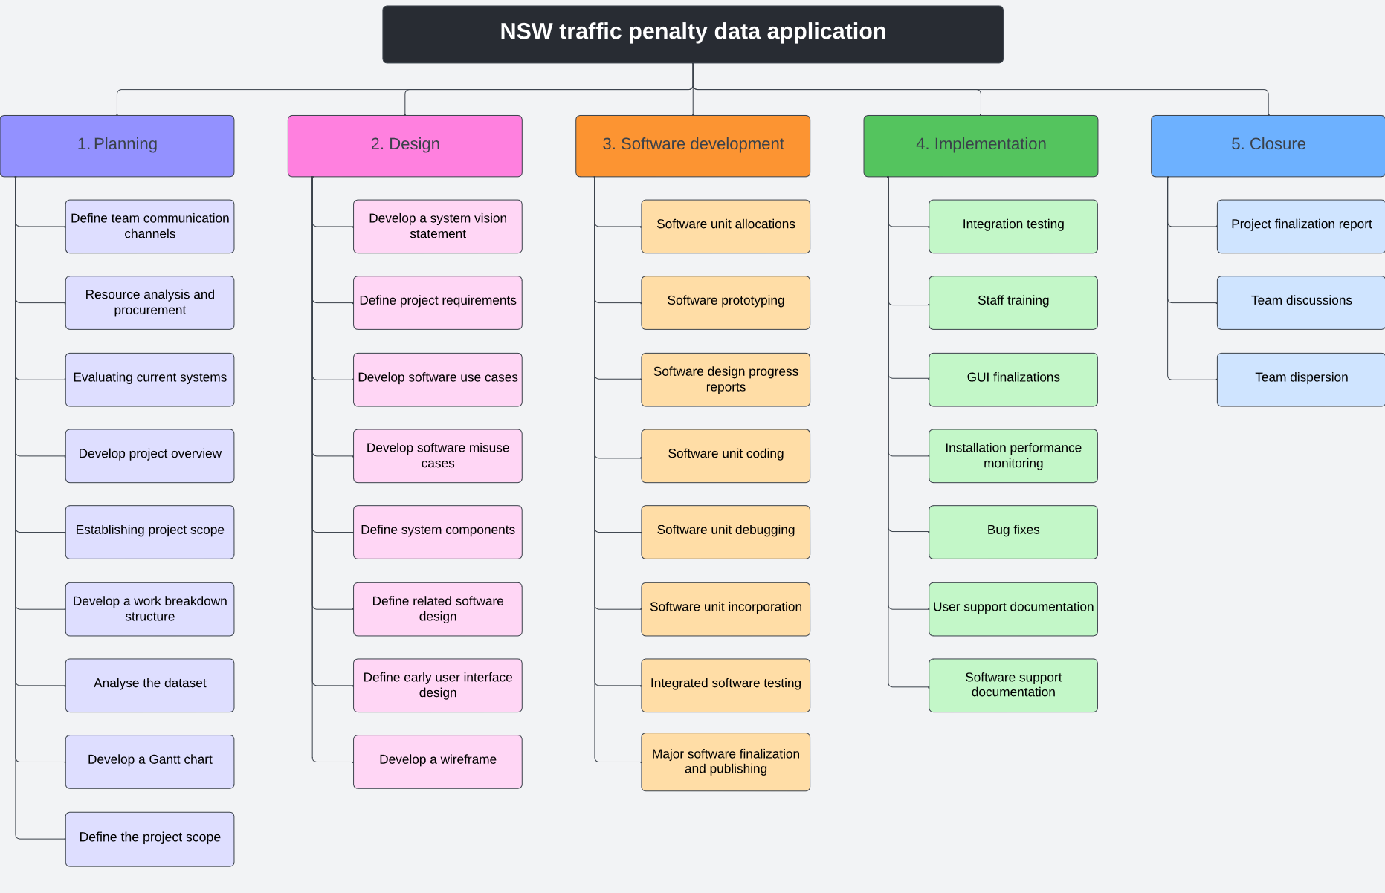

1. **Activity Definition & Estimation**

*From your WBS, define the activities required for your project. You will revise this document and add more detail for part B as you discover more about the project.*

*Each activity should be clearly identified by a number and should match up to your Gantt chart. You should provide some estimations for the time you think each activity will take. This should make it easy to prepare your Gantt chart.*

1. **Gantt Chart**

*This section should contain your Gantt chart. The items in the Gantt chart should match the activity definition from section 3. You should also submit your Gantt chart file separately.*

1. **Bibliography**

Noble, F. (2022, January 19). *Fines issued in NSW last year surge to almost $1 billion worth despite lockdowns*. 9NEWS: https://www.9news.com.au/national/fines-issued-in-nsw-last-year-surge-to-almost-1-billion-dollars-worth-despite-covid-19-lockdowns/f30b5b99-beb3-4536-ba67-e51c56adee56